OM-2244
August 2007
HPI
H2O Power Innovations, LLC

Owner’s Manual

Electric Power Washer
Models 22 & 44

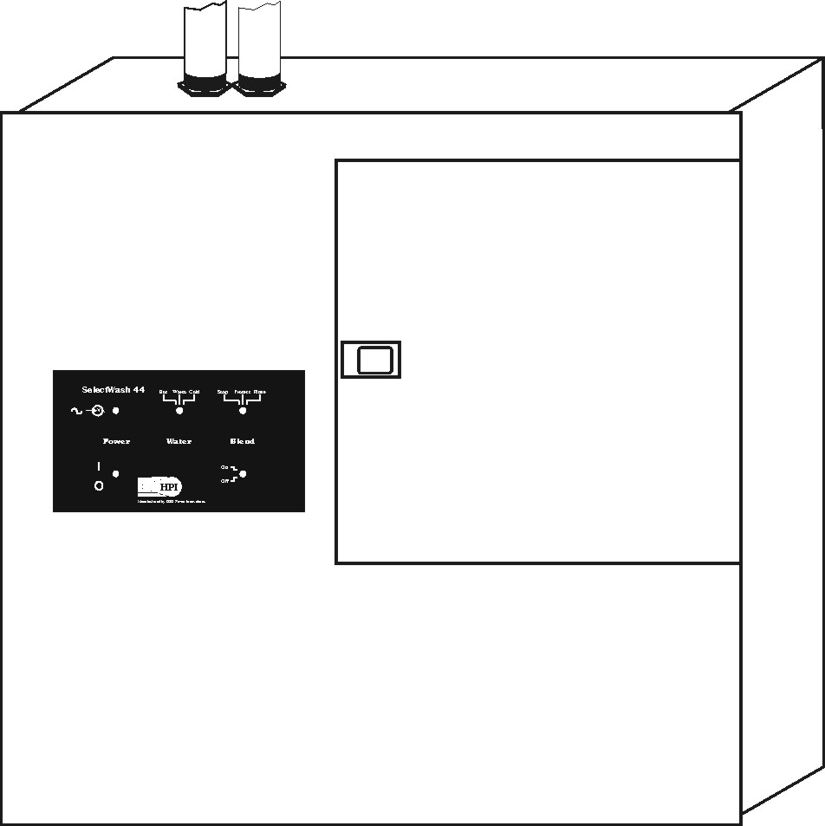

NOTE: Read, understand, and follow this manual and all safety instructions BEFORE using HPI Power Washers.

 Visit our Website at: www.h2opowerinnovations.com

 Or call us at: 1-210-657-4700 or Fax at 1-210-657-4701

Thank you for choosing this Power Washer from HPI.
Congratulations on your purchase of this H2O Power Innovations (HPI) spray washer. This power washer was carefully designed and built to the highest standards of precision and craftsmanship. Each part was thoroughly tested to make sure the quality and performance of this unit will meet all your power washing needs for many years to come. We’ve done our job. Now it’s your turn. Read this manual carefully before using this unit, and keep it handy during use. Always keep this manual with the unit, even if reselling it. HPI products are designed to operate safely and efficiently. It is the owner’s responsibility to operate this unit according to all the instructions and safety guidelines contained in this manual. The operator also must use common sense and judgment when power washing. All efforts were made to be sure the information in this manual was current and accurate at the time of printing. However HPI reserves the right to update, change, alter, or improve both the manual and HPI products without prior notice or incurring any obligation whatsoever.

NOTE: This power washing system is designed for use with soaps, waxes, protectants, cleaners, and rinses. HPI supplies these items in proper mixes and viscosities. Using other chemicals may cause damage to this system and will void your warranty. Use only HPI chemicals and follow all environmental codes and requirements associated with them—read the specific Material Safety Data Sheet (MSDS) that comes with each container of chemicals before use.

Table of Contents

Section 1. Safety

Section 2. Specifications And Rating Labels
Section 3. Features
Section 4. Installation
Section 5. Water and Electric Connections
Section 6. Function of Controls
Section 7. Preparing the Unit for Use
Section 8. Operating the Unit
Section 9. Adjusting the Injector Screw
Section 10. Remote Access Stations
Section 11. Maintenance
Section 12. Parts List and Accessories
Section 13. Troubleshooting
Section 14. Circuit Diagrams
Section 15. Warranty

SECTION 1. SAFETY—Read Before Using

Section 1.1 Safety Alert Symbol and Signal Words

Safety is of utmost importance whenever operating HPI equipment. HPI has included in this manual and on product labels safety information to alert the user to possible hazards that can occur while operating this unit. Please be sure you read, understand, and follow this manual and all labels carefully before operating this unit. Also familiarize yourself with all operational and safety aspects associated with power washing and this product. Each operator should use common sense and sound judgment while operating this unit.


This is the safety alert symbol. It alerts the user to possible hazards that will or may cause personal injury if the directions are not followed carefully. The operator must obey all safety messages that follow this symbol to reduce or avoid potential injury or even death. The safety alert symbol calls attention to the hazard and is used with signal words that designate a degree or level of hazard seriousness. The signal words for product safety are DANGER, WARNING, and CAUTION. The meaning of the signal words is as follows:

DANGER indicates an imminently hazardous situation, which, if not avoided, WILL result in death or serious injury.

WARNING indicates a potentially hazardous situation, which, if not avoided, COULD result in death or serious injury.

CAUTION indicates a potentially hazardous situation, which, if not avoided, MAY result in minor or moderate injury or property damage.

Section 1.2. Safety Symbols and Precautions
WARNING: The following safety symbols are used on labels and in this manual to call attention to and identify possible hazards. When you see the symbols, watch out, and follow the related instructions to avoid the hazard and injury.

 | HIGH PRESSURE SPRAY can cut or pierce skin causing serious injury.  • Keep spray away from your hands, arms, and body.  • Never spray at people or animals.  • Never point gun at yourself or anyone else.  • Wear proper protective clothing.  • Keep children away from spray area.
 | FLYING OBJECTS AND CHEMICALS from washing can injure eyes or blind.  • Always wear safety goggles while spraying to protect your eyes from flying dirt, soap, and chemicals.  • Additionally, wear rubber gloves, suit, and a respirator when told in the Material Safety Data Sheet (MSDS) to do so.
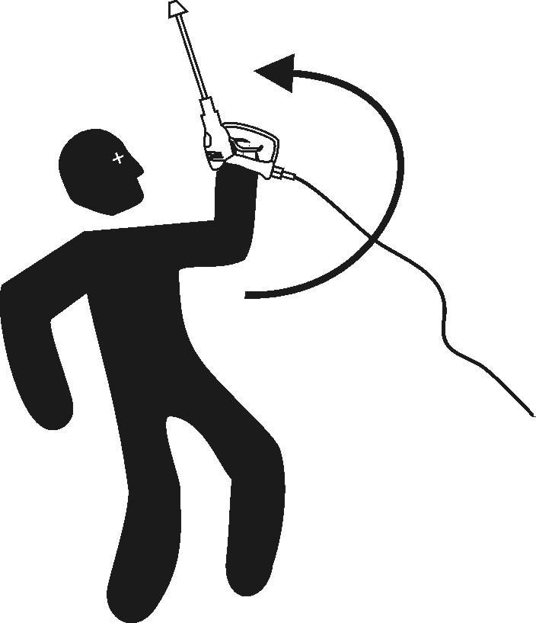 | GUN KICKBACK from high pressure can cause injury.  • Hold gun with both hands.  • Keep a firm grip on the gun during use.  • Never pull gun trigger unless braced and ready.  • Keep good footing and balance during use.
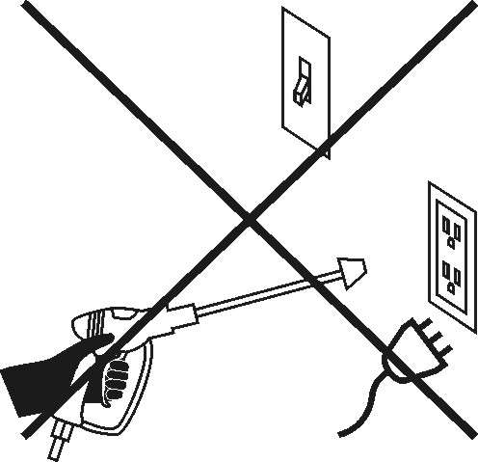 | ELECTRIC SHOCK hazard.  • Do not spray into or on electrical parts.  • Keep spray away from all electric wires or parts  • Do not touch plug with wet hands.
 | ELECTRIC SHOCK can kill.  • Do not touch live electrical parts.  • Install and ground unit according to all national and local codes and ordinances.  • Disconnect input power before servicing unit.
 | CHEMICALS can cause severe skin burns and eye damage.  • Wear protective gloves, safety goggles, and clothes.  • Use only in well ventilated areas.  • Avoid contact with skin and eyes.  • Read and follow all MSDSs for chemicals used.
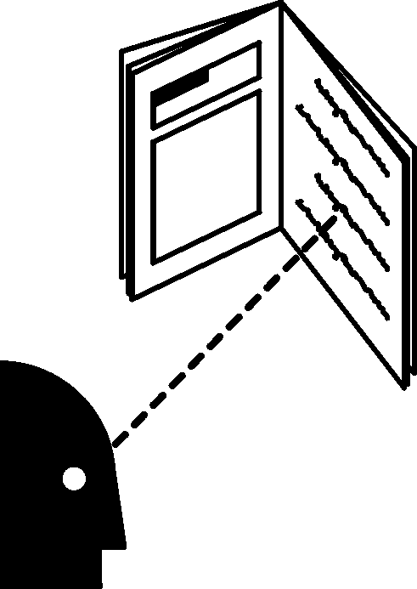 | PROTECT yourself and others.  PRESSURE WASHING can be hazardous.  • Before use, read and follow all labels,  the manufacturer’s instructions, and Material  Safety Data Sheets (MSDSs) for chemicals used.  • Only qualified persons are to install, use, or service this unit.
SLIPPERY SURFACES OR PUDDLES can cause slipping and falling.
• Be sure there is good drainage in the wash area.
- Do not get too close to the spray area.
- High pressure spray can cause falling if you are too close to the spay area.

 | RISK OF EXPLOSION OR FIRE—DO NOT SPRAY FLAMMABLE LIQUIDS.  • Never use explosive or flammable chemicals in this power washer.  - Always read and follow the container label and MSDS for any chemicals used.  - Do not risk severe injury, burns, or fire because of spraying flammable chemicals.
 | WEAR PROTECTIVE GLOVES when handling chemicals to prevent injury.  • Wear rubber or neoprene gloves when handling chemicals.  - For correct type of gloves to use, read and follow the container label and MSDS for the chemicals.  - Wear other protective equipment such as a rubber or waterproof suit and a proper respirator when required by the MSDS for the specific chemicals used.
RISK OF INJURY—STAY ALERT.
• Do not operate this unit when fatigued or under the influence of alcohol or drugs.
- Always read and follow the container label and MSDS for any chemicals used.

LIFTING HAZARD—HEAVY OBJECT.
• These units weigh approximately 112 lbs. (51 kg).
- Always have two persons of adequate physical strength lift, move, or install these units.
- Single person lifting could cause muscle strain or back injury—use assistance when lifting.
• Two persons required to lift unit—use proper lifting techniques or lifting aids to install unit.

BURN HAZARD—WATER TEMPERATURE ABOVE 125° F CAN CAUSE INSTANT BURNS OR SCALDING.
• Check water temperature before use, and set below 125° F.
- This system is designed to handle water temperatures up to 160° F without damaging the unit.
- If using water temperatures above 125° F, take extra precautions against burns and scalding.

Section 1.3 Safe Operating Tips
WARNING: When using this power washer, always follow the safety symbols and precautions in Section 1.2 and the following basic safety tips:
- Operate the pressure washer outdoors or in a bay prepared for high moisture conditions and proper drainage.
- Chemicals used may be harmful or fatal if swallowed.
- Never aim or spray gun at living objects, including people, animals or plants.
- Ensure high-pressure hose connections are secured before and during use.
- Should a leak in the high-pressure hose occur, stop operation immediately and replace hose, securing quick connections before proceeding.
- Periodically check siphon hose inlets for fouling or clogging, replace or clean as needed.
- Be careful to avoid spray injection beneath the skin, should it occur, seek medical attention.
- Be sure work area is clear of grease or oil stains that may cause slipping hazard.
- Never tie open the spray gun under any conditions.
- Never spray water or chemicals on the unit.
- Should a sudden reduction in the pressure or volume of water or chemical occur, shut the unit off immediately to avoid potential serious damage to unit.
- Never operate the unit while tired or fatigued, or under the influence of alcohol or drugs.
- Ensure you have solid surface footing before operating.
- Ensure operating area is clear of clutter and obstacles that may create slipping or tripping hazards.
- Always wear proper clothing to prevent injury and accidental contact with solutions or chemicals.
- It is recommended operator always wear protective eyewear.
- Operate this unit from a stable surface only.
- Grasp spray gun with both hands while in use to avoid kickback.
- Keep water and chemical spray away from all electrical components, wiring or outlets.
- Insure area of use has adequate drainage to avoid pooling liquids that may create a slippery surface.
- Keep spray tip at least 10 inches or more away from surface being cleaned to avoid deflection of spray and surface damage.
- High-pressure spray and/or chemicals may damage some types of surfaces--verify that the surface may be pressure washed by testing a small area first in an area that is hidden.
- High-pressure water can move objects--secure all objects that are to be cleaned to prevent damage or injury.
- Never allow children to operate this unit.
- Never attempt to repair damaged high-pressure spray hoses. If faulty or damaged, always replace them.
- Never touch switches or electric components with wet hands.
- This product is normally provided with a ground fault circuit interrupter (GFCI) built into the power cord. Never attempt to repair a cord, plug, or ground fault circuit interrupter. If damage occurs, replace plug, cord, and ground fault circuit interrupter with identical replacement parts. In some cases, there is no visible cord because the unit is wired directly to a line disconnect box (circuit breaker box) with GFCIs inside protecting the unit. Be sure to test the GFCIs for proper operation periodically.
- Never remove safety tags or warning labels.
- If safety labels are worn or hard to read, replace them with new labels—see Parts List.
- Input water temperature should not exceed 125 degrees F.

Section 2. Specifications and Rating Labels

Model | SelectWash 22 | SelectWash 44
Maximum Pressure | 2000 PSI | 2000 PSI
Normal Output | 2 GPM @ 1300 PSI | 3.1 GPM @ 1700 PSI
Rated Input | 120 VAC @ 13.9 Amps | 240 VAC @17.1 Amps
Back Flow Protection | Internal Back Flow Preventor | Internal BackFlow Preventor
Plug Type | NEMA 5-20 Plug | NEMA 6-20 Plug
AC Power Circuit Protection | Ground Fault Circuit Interrupter (GFCI) | Ground Fault Circuit Interrupter (GFCI)
Net Weight | 105 Lbs. (48 kg) | 112 Lbs. (51 kg)

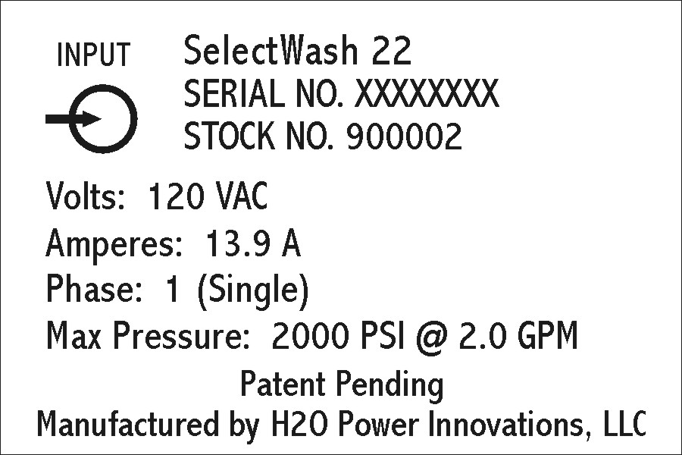
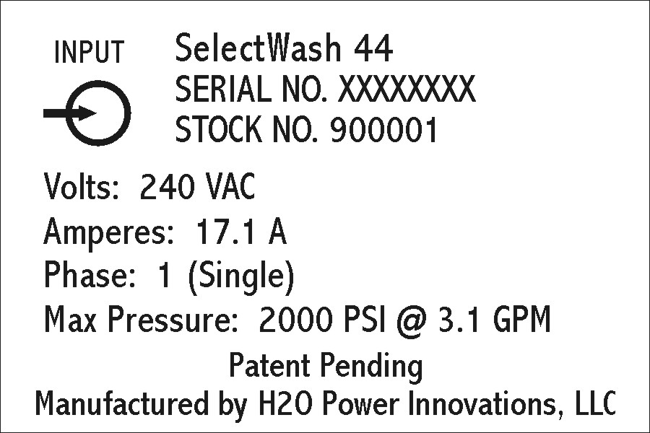

Section 3. Features

HPI products have the latest innovations in electric power washers. Here are some of these major benefits to our customers:
- Starts at the flip of a switch!
- 115 Volts or 230 Volts Models available.
- Always ready when you are!
- No gas! No fumes! No dangling siphons!
- Soft water and hot water connectable.
- Custom installation.
- Space saving wall mount.
- Ideal for washing cars, boats, and RV’s.
- Works fantastic on driveways, sidewalks, patios, outdoor furniture and play equipment, and decking!
- Select up to three solutions including soap, protectant, and rinse.
- Storage for three solutions at 1 gallon each—wash 20 + cars in one fill.
- Various solutions can be made available for this product.

Section 4. Installation

WARNING: This product is intended for inside installation only. HPI power washing units are designed to be installed only by authorized dealers and installers or by licensed electricians and plumbers. This unit weighs approximately 100 lbs. Only qualified persons are to install this unit and shall follow these additional safety steps:
- Install unit according to all applicable building codes and local ordinances.
- Connect only to properly grounded receptacle.
- These units are to be installed only with a GFCI cord or permanent connection to a GFCI protected line.
- Inspect electrical power cord before using—never use with a damaged cord.
- Test Ground Fault Circuit Interrupters (GFCIs) before use.
- Connect to Individual Branch Circuit Only fused according to National Electrical Code (NEC) and local building requirements.
- Have two persons of adequate physical strength lift, move, or install this unit.

Section 4.1 Choosing a Location

A proper location includes the following:
- Mount the system on a wall of sufficient strength to safely support its weight.
- Select a location where water leaking from the system will not cause damage to the surrounding area.
- Provide access to adequate water supply including pressure and volume—this is essential—3/4 inch diameter piping or tubing is recommended for connection to the water supply.
- Ensure that water pressure will not fall below 50 psi with a flow rate of 4 gallons per minute during operation.

Section 4.2 Preferred Installation for Stud Walls: (Attached to Two Studs—See Figure 1)
1. Locate studs in wall with 16 inches from center to center of studs.
2. Remove packaging materials and contents from storage compartment.
3. Remove screws holding cover onto unit including screws within the storage compartment on the left side.
4. Remove Cover.
5. Drill pilot holes for 6 lag bolts to be mounted in studs on 16 inch centers at distances indicated in the mounting diagram. There are 4 possible hole locations on the base (back) of the product that may be used for each stud--only 3 lag screws need to be used on each stud to mount unit. Choose the locations that work best for installation considering ease of access when installing the screws.
6. Insert the supplied lag bolts into the top holes leaving 3/8 inch of the shaft visible.
7. Have two people of adequate physical strength lift the unit into place over the two visible lag bolts.
8. Tighten the two lag bolts to hold the unit in position.
9. Insert and tighten the remaining 4 fasteners (2 on each side).
10. Reattach front cover of unit installing all screws. Be sure chemical hoses are not trapped behind the bottle shelf.

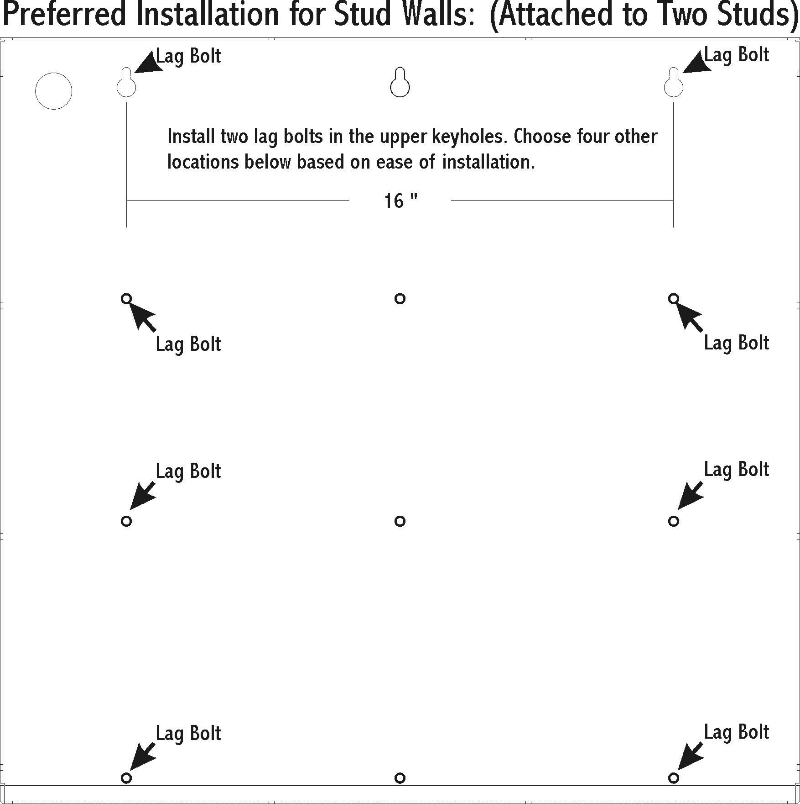

Figure 1. Installation onto Two Studs

Section 4.3 Preferred Installation for Concrete Walls (See Figure 2)

1. Locate best place for installation.
2. Remove packaging materials & contents from Storage Compartment.
3. Remove screws holding cover onto unit including screws within the storage compartment on the left side.
4. Remove cover.
5. Dill pilot holes for 9 concrete screws. There are 12 possible hole locations on the base of the product that may be used for mounting as indicated in the diagram. Choose the locations that work best for installation considering ease of access when installing the screws.
6. Insert the concrete screws into the top holes leaving 3/8 inch of the shaft visible.
7. Have two people of adequate physical strength lift the unit into place over the 3 visible screws.
8. Insert and tighten the remaining fasteners and tighten the top fasteners.
9. Reattach front cover of machine installing all screws. Be sure chemical hoses are not trapped behind the bottle shelf.

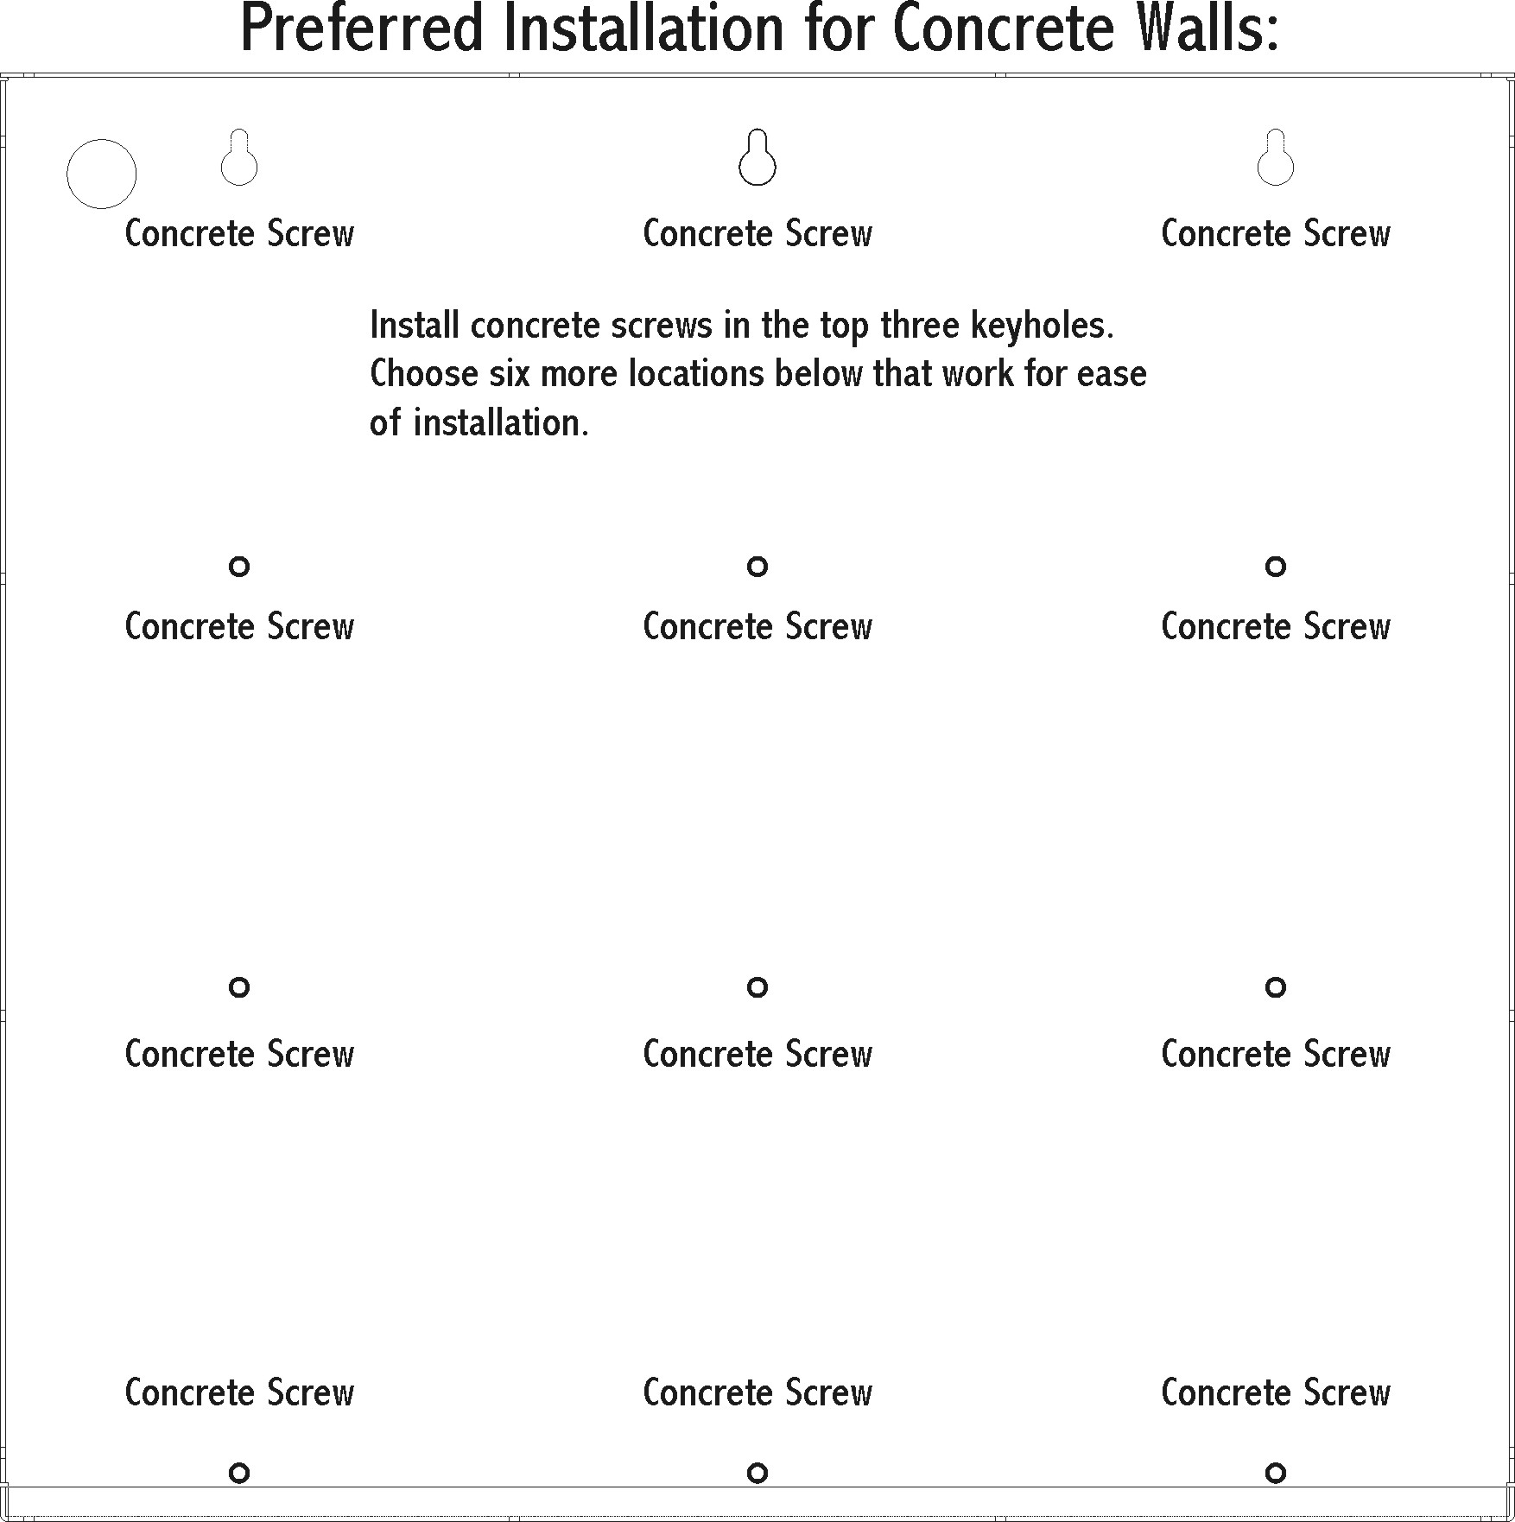

Figure 2. Installation onto Concrete Walls

Section 4.4 Installation for Stud Walls (Attached to One Stud—See Figure 3)

1. Locate stud in wall.
2. Remove packaging materials and contents from storage compartment.
3. Remove screws holding cover including screws within the storage compartment on the left side.
4. Remove cover.
5. Dill pilot holes for 3 lag bolts in one vertical line. There are 4 possible hole locations on the base (back) of the product that may be used for the stud. Only 3 lag screws need to be used. Choose the locations that best work for installation considering ease of access when installing the screws.
6. Using a drill, insert four EZ toggles by drilling them into the drywall. Two toggles should be used on each vertical line. Two of the toggles should be used for the top holes and the additional toggles should be used on the lower half of the mounting base.
7. Insert the bolts and screws in the top holes leaving 3/8 inch of the shaft visible.
8. Have two people of adequate physical strength lift the unit into place over the three visible fasteners.
9. Tighten the fasteners to hold the unit in position.
10. Insert and tighten the remaining fasteners.
11. Reattach front cover of machine installing all screws. Be sure chemical hoses are not trapped behind the bottle shelf.



Figure 3. Installation onto One Stud

Section 5. Water and Electric Connections
WARNING: Be aware of and follow all local codes and ordinances when installing and using this unit.

Section 5.1 Water Connections

1. Connect Cold Water Line to unit (on the right when facing the unit).
2. Connect Hot Water Line to unit (on left when facing the unit).
3. Turn on water supply and verify that no leaking occurs.
Note: In some cases a system with hot and cold water connections may be connected to cold water only. In this case cold water should be connected to both the cold and hot water inlets. Failure to do this will cause leaking and possible damage to the unit.

Section 5.2 Electric Connections

1. Plug electric power cord into the supply receptacle—be sure the cord does not come in contact with water lines. Do not handle plug or power cord with wet hands.
2. Test the Ground Fault Circuit Interrupter (GFCI) to verify that it is operating properly.

Section 6. Function of Controls

Here is the nameplate with all the controls on it. The controls are the same for both the SelectWash 22 and 44 Models. The SelectWash 22 is shown for this typical example.

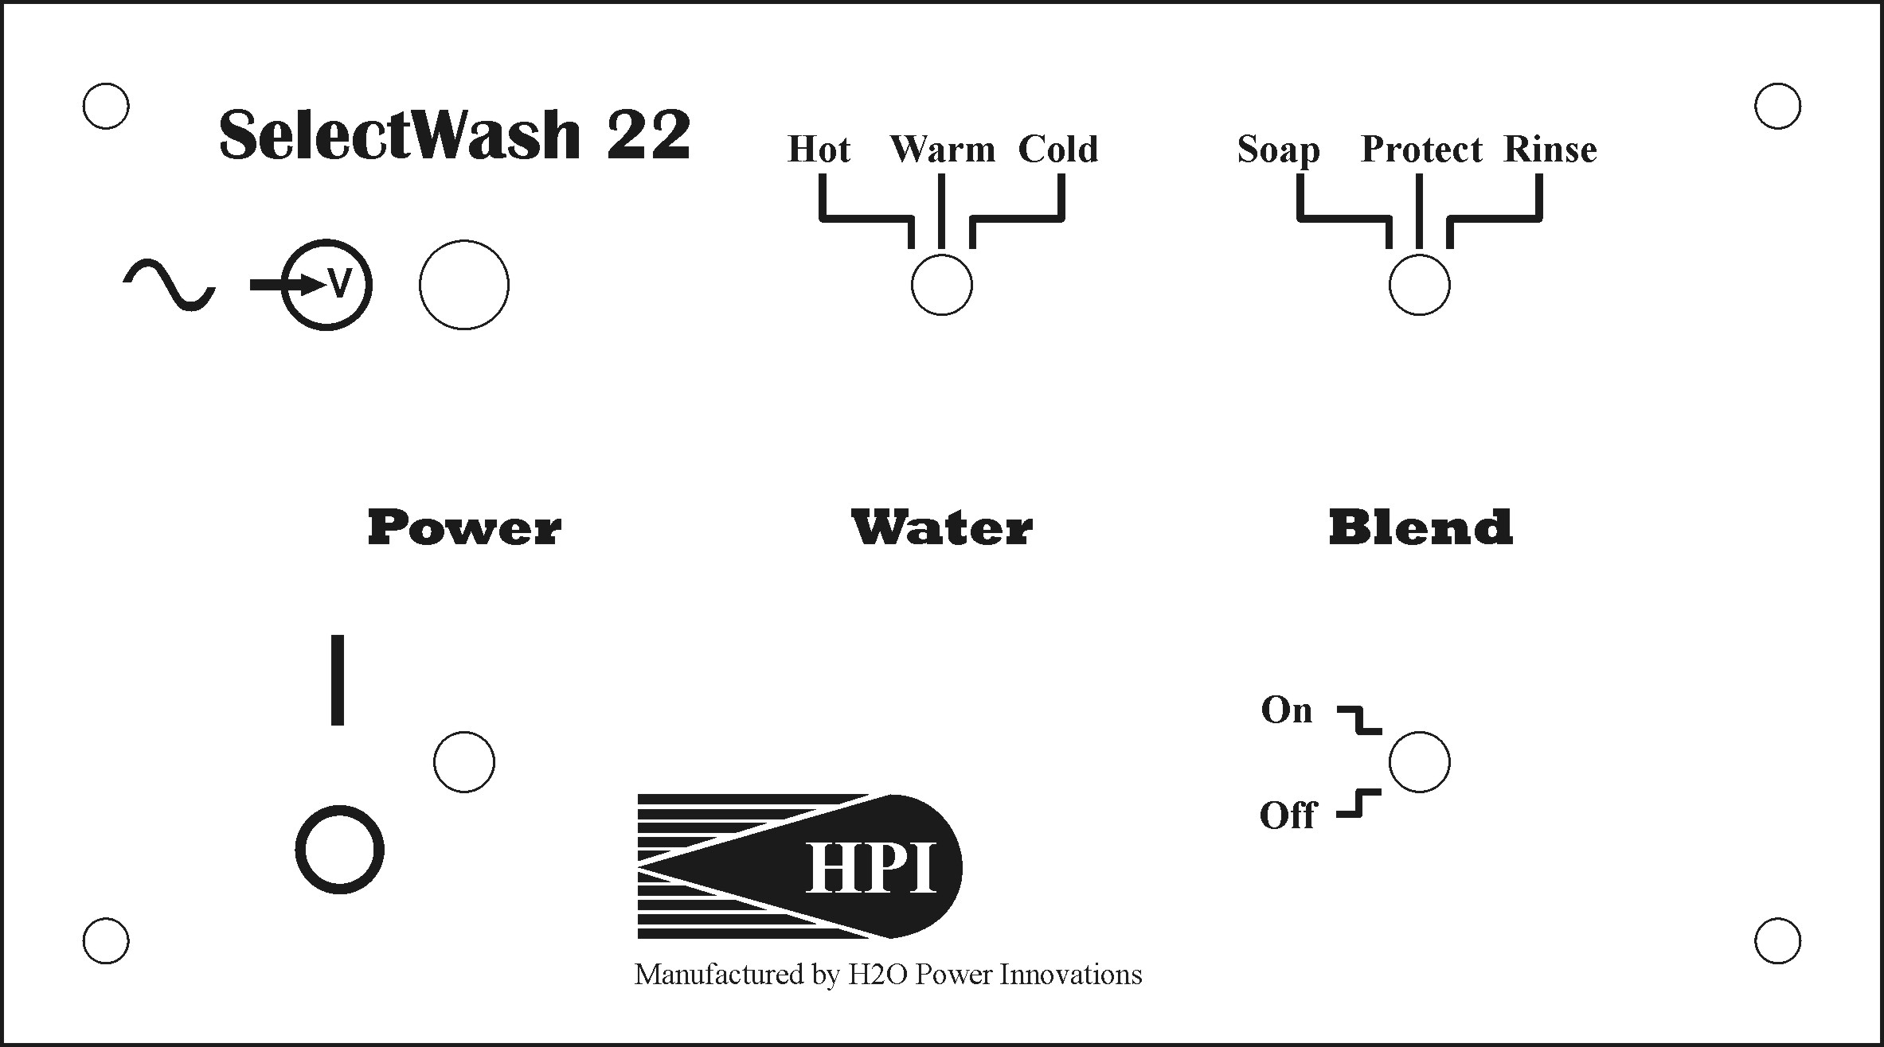

5

1
3

4
2

- Power Indicator Light – When lit, the unit is turned On and high-pressure water is ready in the outlet hose and gun.
- Power Switch – This switch turns the system On or Off. The system is On when it is in the up position, and Off when it is in the down position. The symbols for ON and Off are I and O. Use this switch to turn the unit On and Off.
- Water Temperature Switch – This switch provides selection between Hot, Warm, and Cold water temperature. Place the switch in the desired position before operation.
- On/Off Blend Switch – When in the On/up position a chemical valve opens to allow chemicals to blend with the water. In the Off position the chemical valve is turned off. Place switch in desired position.
- Blend Selection Switch – This switch is used to select which chemical in the storage compartment will be used. Place this switch in the desired position to suit the job.

Section 7. Preparing the Unit for Use

WARNING: Chemicals can be hazardous. Read and follow container labels and Material Safety Data Sheets (MSDSs) before use. Wear proper eye, hand, and body protection when handling and working with chemicals.

Install chemicals as follows:
- Open chemical door.
- Remove cap from chemical container, and place bottle into chemical area.
- Insert feed hose through new cap, and screw new cap with hose onto bottle.
- Close chemical door.

This HPI Power Washer has a Blending Function that may be used with soaps, protectants, and rinses. The blend system is set up at the factory to provide a 100-to-1 blend of water and chemical. An adjustment screw, located on the solenoid inside the storage compartment, allows adjustment between 80-to-1 and 120-to-1. These numbers are only approximate since the chemical mix ratio depends heavily on the viscosity of the fluid being injected and water pressure entering the system. To get a more accurate reading, record the amount of chemical used in one minute. Then compare it to the volume of water provide by the specific model of pump (see specifications). If higher concentrations of chemicals are needed, turn adjusting screw on solenoid until the desired mixture is obtained. We recommend using the lowest ratio of chemical to water that will provide satisfactory washing results
Before using the system, connect a hose to the outlet, a spray gun to the end of the hose, and a tip on the end of the wand. Verify that the trigger is in the Off position. Inspect all hoses and gun components for damage. Replace any damaged components.

Make sure you have read and understood all safety information and are aware of all risks and hazards associated with using this product. Additionally, be familiar with all warning symbols and their meanings.

Turn the Power Switch On, and let the pump run until sufficient pressure is reached. It should turn off automatically in a few seconds when this occurs. Look for leaks. If no leaks occur, the system is ready for use.

Section 8. Operating the Unit

WARNING: Power Washing can be hazardous. Keep spray away from hands and body. Wear eye and body protection. Before use, read and follow all safety precautions in this manual, all safety labels, and the MSDSs for chemicals used.

- Select the surface to be cleaned.
- Be sure the reservoirs contain the proper chemicals needed for the specific cleaning job—install chemicals as needed.
- Be sure the quick connects are secure for both the high-pressure spray hose and spray tips.
- Open the water inlet valve.
- Select the chemical to be used or put Blend switch in the Off position.
- Turn on Power switch to start unit.
- Firmly grasp spray gun with both hands before pressing trigger to avoid kickback.
- Aim spray gun in safe direction and hold it no closer than 10 inches from the surface to be sprayed.
- Begin the spaying operation.
- Once application of the selected chemical is completed, selection of either another chemical or water can be done without turning off the unit. However, the spray gun must be turned off (trigger released) before making the change.
- Turn Off the unit and pull gun trigger to release pressure in the system—do not leave unit On and unattended.

Section 9. Adjusting Injector Screw

WARNING: Have only qualified persons following standard safety practices perform this procedure. Two persons are needed to complete this adjustment. Wear safety glasses, protective gloves, and proper clothing while doing this procedure.
- Turn Off the unit.
- Remove solutions from the solutions cabinet.
- Fill a container with water, and connect it to one of the unit’s solution intake hoses.
- Place the Blend Selection switch in the position where the water is connected.
- Place Water switch in the Warm position.
- Place the Blend switch in the On position.
- Have one person ready to operate the wand.
- Turn On unit.
- Locate injector adjustment screw in the rear of the solution storage cabinet.
- Using a flat screwdriver, have one person turn the adjustment screw counterclockwise one full turn.
- While pointing gun in a safe direction, press gun trigger, and slowly begin turning screw clockwise until water begins to flow from the bottle into the injector.
- Once water begins to flow, turn screw an additional ¼ turn clockwise.
- If problem is solved, turn unit Off, remove water container, replace solutions into the cabinet, and resume operation.
- If pump begins to vary in speed and output pressure begins to drop, turn screw counterclockwise until it stops.
- If water no longer flows from the bottle, water pressure may be too low.
- Check and correct the water pressure problem, replace chemicals, and continue operation.
- If the problem still exists, call the factory for help.

Section 10. Remote Access Stations

Remote access stations may be provided to allow you to quick connect your hose and wand at locations around your yard or business. Simply connect the hose and wand, open the manual valve (if supplied), turn on and select output (if supplied with remote panel) and operate as normal. Be sure to turn off and/or shut the valve, and bleed system by opening main wand valve before disconnecting your hose and wand.

CentralWash Systems provided without freeze protected outlets will require draining prior to exposure to freezing weather. This can be done by disconnecting your hose at the unit, opening all remote access stations, and applying air pressure into the hose until all water is purged from the line. Begin closing each valve starting with the one closest to the unit applying compressed air after closing until the last valve is closes. The main unit should be located in a non-freezing location or it must be drained additionally. Contact your local dealer for information on this process.

Section 11. Maintenance

Since your new H2O pressure washer is electric, it requires very little maintenance. However, following these tips will help prolong the operating life of your unit. For any internal work, contact a factory service representative.

Procedure | Daily | 30 Days | 3 Months | 6 Months | 12 Months
Check for water leaks | X
Check condition of hose & gun parts | X
Check for broken or worn parts | X
Test the GFCI |  | X
Inspect water inlet filter |  | X
Inspect high-pressure nozzle |  | X
Test water pressure |  |  | X
Check electrical cord & connections |  |  | X
Check oil level in pump |  |  |  | X
Change oil in pump |  |  |  |  | X
Rinsing lines & hoses—See below

Rinsing the lines and hoses: In some cases it may be necessary to rinse the chemical inlet hose and injector to prevent clogging or component deterioration. To do this insert the chemical inlet hose into a container of clean water. Run the system spraying water until the components are flushed fully. Reconnect chemical inlet hose to the proper location, and resume operation.

Note: Rinse the lines and hoses whenever the unit will not be used for an extended period of time. This will keep them clean, prevent clogging, and have them ready for use in the future.

Section 12. Parts List and Accessories

To maintain the original factory safety and performance of this unit, use only genuine factory replacement parts. The model name and serial number are required when ordering parts.

Part Number | Description | Quantity | Category / Model
100017 | Quick Disconnect, 3/8 Female Plug | 1 | Accessory
100018 | Quick Disconnect, ¼ Female Socket | 1 | Accessory
100019 | Spray Gun | 1 | Accessory
100020 | Wand, 36” | 1 | Accessory
100021 | Tip, Green #5 | 1 | Accessory/44’s
100022 | Tip, White #5 | 1 | Accessory/44’s
100030 | Pressure Wash Hose, 3/8” x 50 ft. 3,000 psi | 1 | Accessory
100031 | Strainer, Chemical Hose | 1
100032 | Cap, bottle | 1
100048 | Fuse, 0.25 amp | 1 | SelectWash 44’s
100058 | GFCI, 240 VAC 20 amps | 1 | SelectWash 44’s
100060 | Label, Warning Tag, Cord | 1
100061 | Owner’s Manual | 1
100065 | Label, Rating | 1 | SelectWash 44’s
100066 | Label, Warning | 1
100067 | Label, Fuse | 1
100070 | Power2Clean | 0 | Accessory
100071 | Power2Protect | 0 | Accessory
100072 | Power2Rinse | 0 | Accessory
100075 | Tip, Green #4 | 1 | Accessory / 22’s
100076 | Tip, White #4 | 1 | Accessory / 22’s
100077 | Fuse, 0.5 amp | 1 | Accessory / 22’s
100078 | GFCI, 120 VAC 20 amps | 1 | SelectWash 22’s
100079 | Label, Rating | 1 | SelectWash 22’s

Section 13. Troubleshooting
WARNING: Have only qualified persons familiar with and following standard safety practices perform troubleshooting procedures. If the following procedures do not solve the problem, call the factory for service (see phone number on front of this manual).

TROUBLE | PROBABLE CAUSE | REMEDY
Unit will not start or turn on; completely inoperative. | Power cord not plugged into energized receptacle.  Power switch in Off position.  GFCI not On or tripped. | Plug in Power cord and turn on supply power to receptacle.  Place Power switch in On position.  Reset GFCI. If indicator light is not on, there is a blown fuse; replace fuse.
No spray from nozzle when trigger is pulled; motor does not run. | Low or no water pressure.  Incorrect or damaged nozzle. | Check and be sure input water is on and is supplying at least 50 psi to unit.  Check for proper nozzle and for damage or dirt; replace or clean as needed.
Low or fluctuating spray pressure. | Varying water input pressure.  Kink or clog in water input line.  Kink in high pressure output hose.  Clogged hose or lines.  Water inlet filter plugged. | Check and correct water input pressure problems.  Remove kink or clog.  Remove kink and straighten out hose.  Rinse system (see Section 10).  Remove filter; clean or replace.
No solution flow. | Blend switch in Off position.  Plugged or clogged solution hose. | Place Blend switch in On position.  Check and remove clog from solution hose.
Water leaks from gun, hose, or nozzle | Turn off unit and inspect parts for wear or damage. | Tighten or replace parts as needed.
Water leaks from inside unit. | Do not operate unit. | Turn off unit. Disconnect input power and turn off input water. Call factory for service. Do not try to service or take unit apart—serious injury could happen. Get a qualified factory service person to fix unit.
Pump speed varies and water pressure drops. | Low or no water pressure to unit.  Water pressure is okay, but problem continues. | Check and be sure input water is on and is supplying at least 50 psi to unit.  Adjust the injector screw (see Section 8).
Spray pressure okay; cleaning inadequate. | Water temperature too low.  Chemical level low or lines clogged. | Check and reset temperature.  Check chemical level and lines; refill or clean as needed.

Section 14. Circuit Diagrams

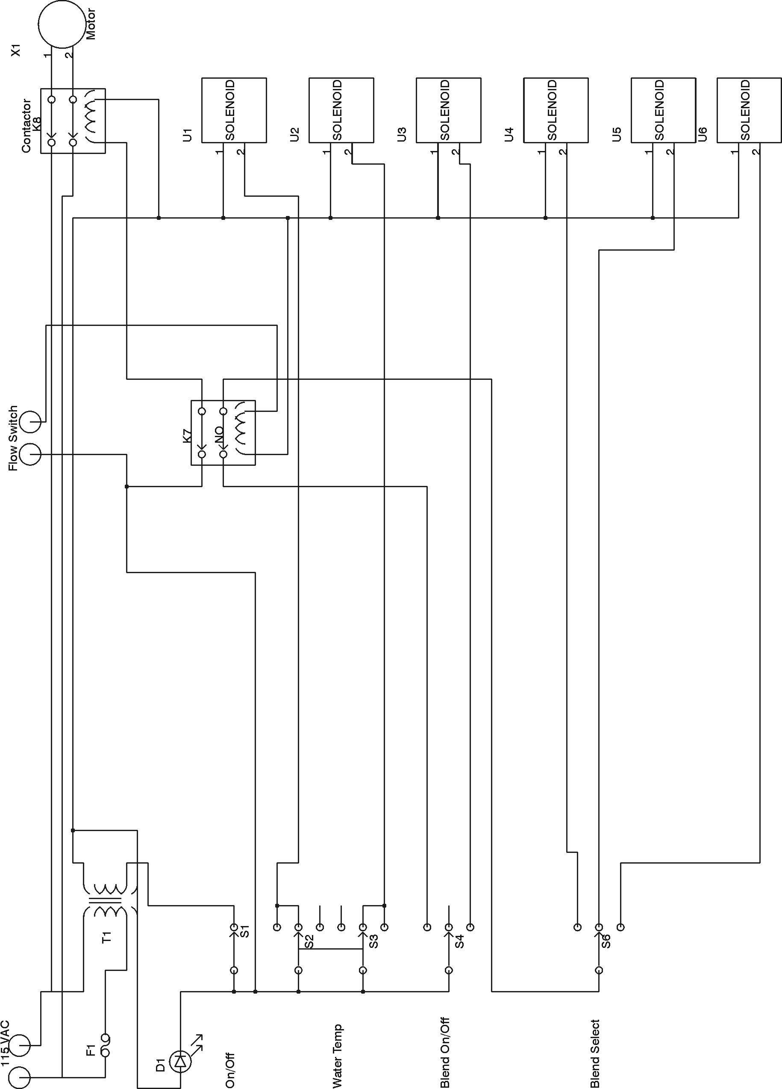

Circuit Diagram for 115 Volts Models

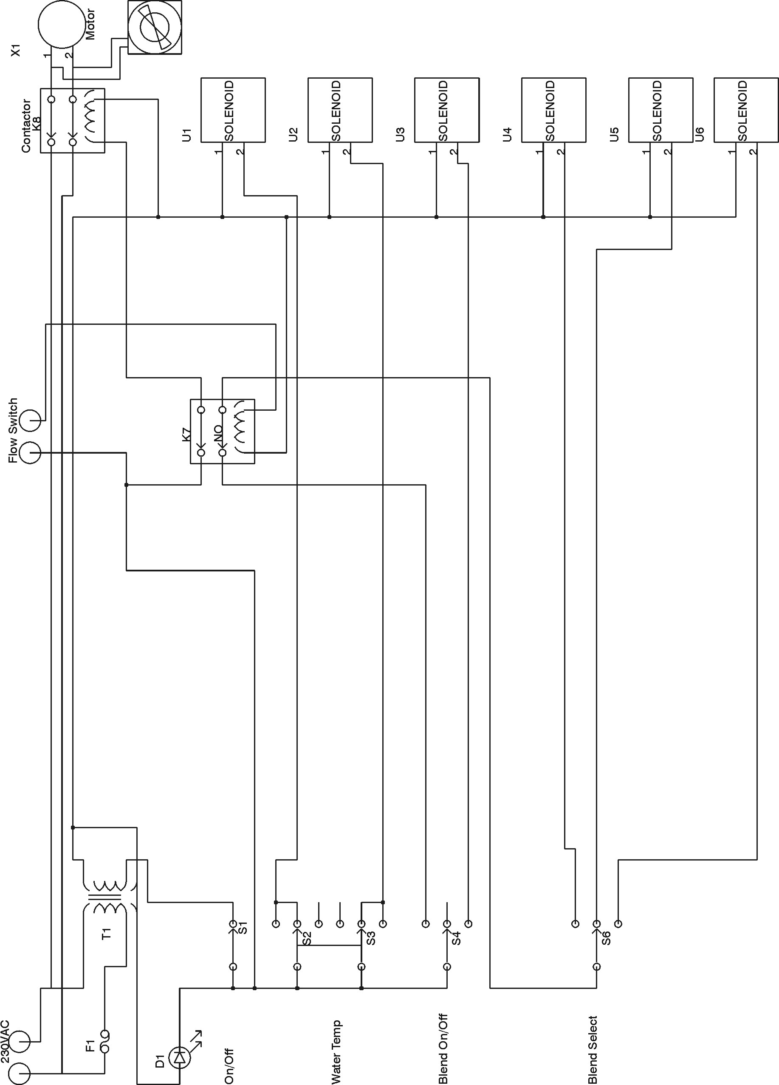

Circuit Diagram for 230 Volts Models

Section 15. Warranty

This limited warranty supersedes all previous HPI warranties and is exclusive with no other guarantees or warranties expressed or implied. LIMITED WARRANTY⎯Subject to the terms and conditions below, HPI warrants to its original retail purchaser that new HPI equipment sold after the effective date of this limited warranty is free of defects in material and workmanship at the time it is shipped by HPI. THIS WARRANTY IS EXPRESSLY IN LIEU OF ALL OTHER WARRANTIES, EXPRESSED OR IMPLIED, INCLUDING THE WARRANTIES OF MERCHANTABILITY AND FITNESS. Within the warranty periods listed below, HPI will repair or replace any warranted parts or components that fail due to such defects in material or workmanship. HPI must be notified in writing within thirty (30) days of such defect or failure, at which time HPI will provide instructions on the warranty claim procedures to be followed. HPI shall honor warranty claims on warranted equipment listed below in the event of such a failure within the warranty time periods. All warranty time periods start on the date that the equipment was delivered to the original retail purchaser.
For Residential Installations
12 Months⎯Parts and Labor
90 Days⎯On Accessory Items.
For Commercial Installations
6 Months⎯Parts and Labor
90 Days⎯On Accessory Items.

HPI’s Limited Warranty shall not apply to:
1. Consumable components, such as spray guns, spray tips, hoses, and connectors.
2. Items manufactured by others, but furnished by HPI, such as motors, pumps, or trade accessories. These items are covered by the manufacturer’s warranty.
3. Equipment modified by any party other than H2O, improperly installed, improperly operated, misused, neglected and not given reasonable and necessary maintenance, operated outside of the specifications, design, or use for which it was intended.

For a warranty claim, the exclusive remedies shall be, at HPI’s option: (1) repair; or (2) replacement; or, (3) where authorized in writing by HPI in appropriate cases, the reasonable cost of repair or replacement at an authorized H2O service station; or (4) payment of or credit for the purchase price (less reasonable depreciation based upon actual use) upon return of the goods at customer’s risk and expense. HPI’s option of repair or replacement will be F.O.B., Factory at San Antonio, Texas, or F.O.B. at an HPI authorized service facility as determined by HPI. No compensation or reimbursement for transportation costs of any kind will be allowed.

TO THE EXTENT PERMITTED BY LAW, THE REMEDIES PROVIDED HEREIN ARE THE SOLE AND EXCLUSIVE REMEDIES. IN NO EVENT SHALL HPI BE LIABLE FOR DIRECT, INDIRECT, SPECIAL, INCIDENTAL OR CONSEQUENTIAL DAMAGES (INCLUDING LOSS OF PROFIT), WHETHER BASED ON CONTRACT, TORT, OR ANY OTHER LEGAL THEORY. ANY EXPRESS WARRANTY NOT PROVIDED HEREIN, AND ANY IMPLIED WARRANTY, GUARANTY, OR REPRESENTATION AS TO PERFORMANCE, AND ANY REMEDY FOR BREACH OF CONTRACT, TORT, OR ANY OTHER LEGAL THEORY WHICH, BUT FOR THIS PROVISION, MIGHT ARISE BY IMPLICATION, OPERATION OF LAW, CUSTOM OF TRADE, OR COURSE OF DEALING, INCLUDING ANY IMPLIED WARRANTY OF MERCHANTABILITY OR FITNESS FOR PARTICULAR PURPOSE, WITH RESPECT TO ANY AND ALL EQUIPMENT FURNISHED BY HPI IS EXCLUDED AND DISCLAIMED BY HPI.

Some states in the USA do not allow limitations of how long an implied warranty lasts, or the exclusion of incidental, indirect, special or consequential damages, so the above limitation or exclusion may not apply to you. This warranty provides specific legal rights, and other rights may be available, but may vary
from state to state.

In Canada, legislation in some provinces provides for certain additional warranties or remedies other than as stated herein, and to the extent that they may not be waived, the limitations and exclusions set out above may not apply. This Limited Warranty provides specific legal rights, and other rights may be
available, but may vary from province to province.

H2O Power Innovations, 18975 Marbach Lane, Unit 411, San Antonio, TX 78266
International Headquarters−USA
USA Phone: (210) 657-4700
USA & Canada FAX: (210) 657-4701

Please write down and keep the following information with your personal records.
Always provide the Model Name and Serial Number when making inquiries about this product.
Contact a DISTRIBUTOR or SERVICE AGENCY near you for help with Warranty issues.

Model Name: _______________________________
Serial Number: ______________________________
Purchase Date (Date when equipment was delivered to original customer.): _____

Distributor Name: ____________________________________

Address: ____________________________________________
City: ________________________________________________
State & Zip Code: _________________________________________

PRINTED IN USA. OM-2244 P.N. 100061 © 2007 H2O Power Innovations

